DC Machines Review:
- Machines have simple (mechanical) commutation.
- Wound Field Machines have independent control of field and torque producing current.
- Can control speed by controlling armature voltage.
- Can control torque (and subsequently speed) by controlling armature current.

DC Machines

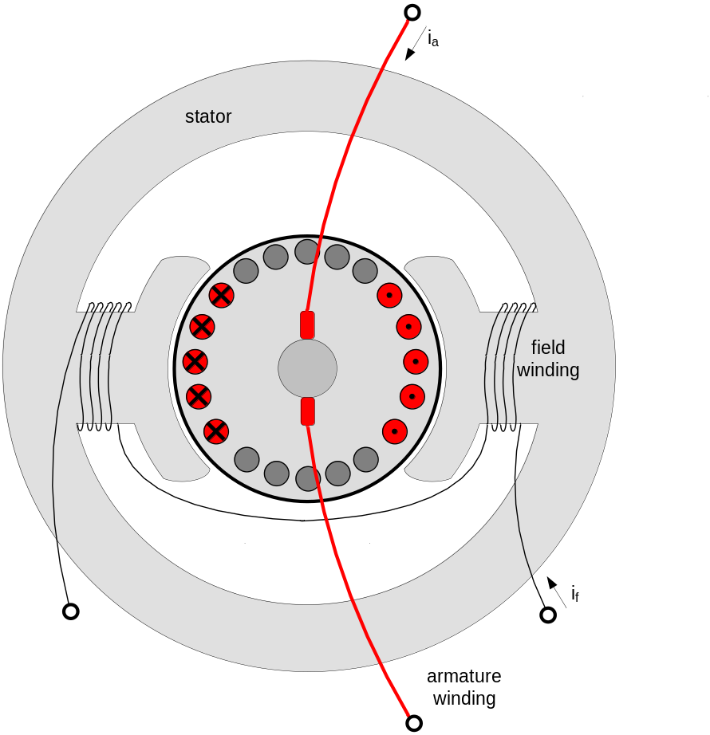
Conceptual Diagram of the Basic Structure of a Wound Field DC Machine

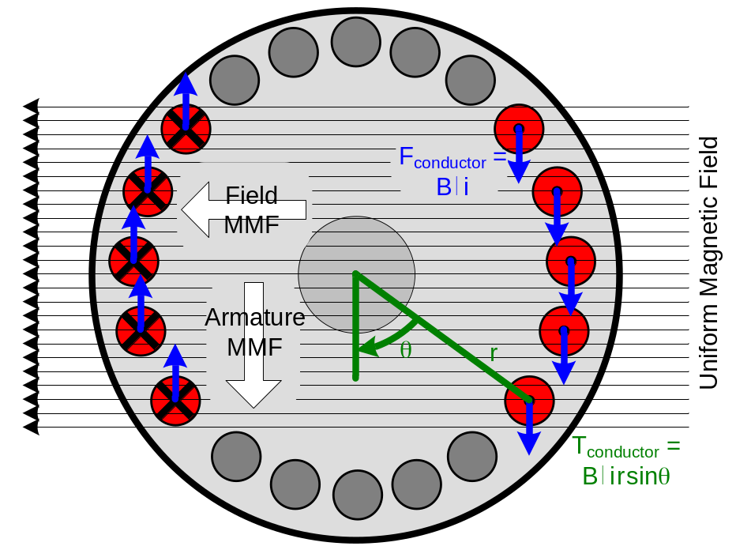
Simplified Torque Production Mechanism in DC Machines

DC Machines Differential Equations:
Armature Circuit  v_{a} = R_{a} i_{a} + L_{a} + e_{a}  where  v_{a} - armature voltage  i_{a} - armature current  R_{a} - armature winding resistance  L_{a} - armature winding inductance  e_{a} – back electro motive force (EMF)  Back EMF  e_{a} = K_{f} i_{f} ω = K_{e} ω  where  e_{a} – back electro motive force (EMF)  K_{f} – field constant (geometry dependent)  i_{f} – field current  ω – rotor speed  K_{e} – back EMF constant (at a fixed field current) | Field Circuit  v_{f} = R_{f} i_{f} + L_{f}  where  v_{f} - field voltage  i_{f} - field current  R_{f} - field winding resistance  L_{f} - field winding inductance  Torque Equation  T_{em} = K_{f} i_{f} i_{a} = K_{t} i_{a}  where  T_{em} –electromagnetic torque produced by the motor  K_{f} – field constant (geometry dependent)  i_{f} – field current  i_{a} – armature current  K_{t} – torque constant (at a fixed field current)

Flux Distribution in DC Machines

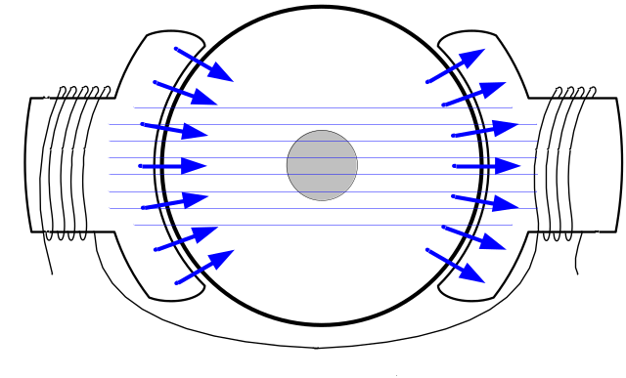
Flux with Field Excitation Only
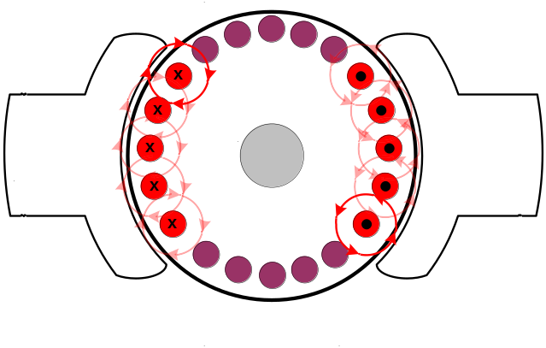
Flux with Armature Excitation Only
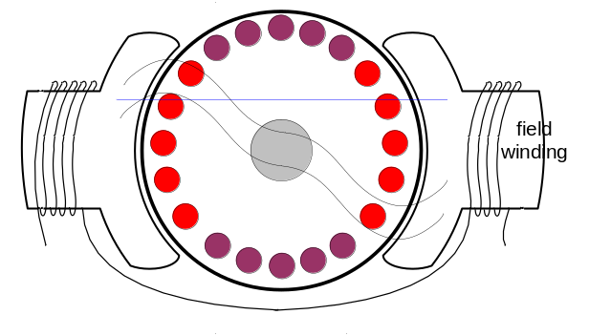
Flux with Field and Armature Excitation

Problem: Skewing of the field flux is known as Armature Reaction.

Armature Reaction Mitigation Techniques:

- Rotate the brushes (helps for unidirectional applications only)
- Add interpoles
- Add compensating winding

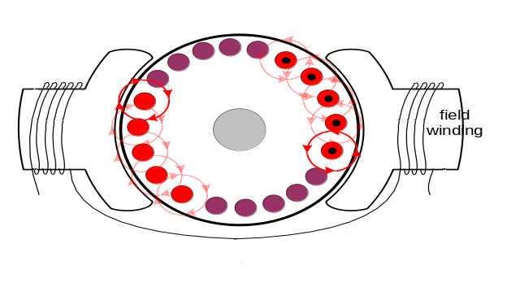
Rotation of Brushes
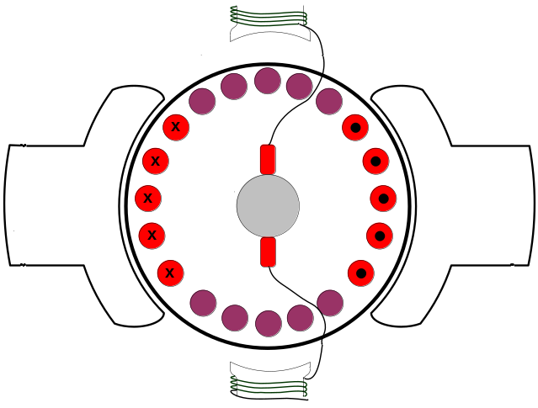
Interpoles
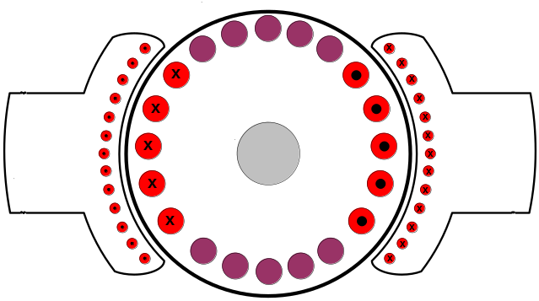
Armature Compensating Winding

Note: BLDC Motors also have armature reaction effects.

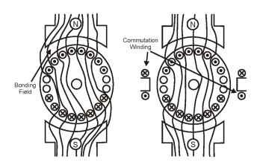
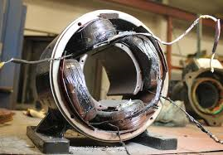
Interpoles Field Windings
DC Machine with Interpoles (Commutation Windings)

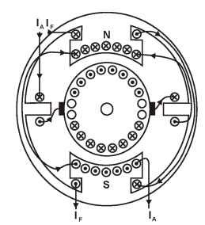
DC Machine with Interpoles and Compensating Windings

Speed/Torque Capabilities of DC Machines

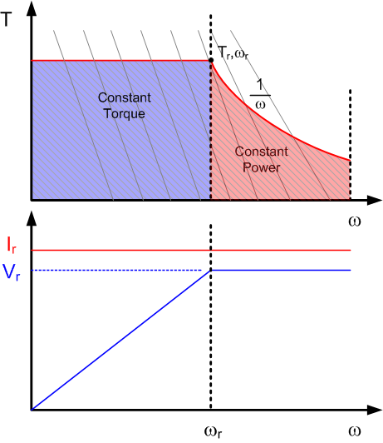
Capability curve for separately excited DC Machine

Limitations:
- Continuous – Thermal Limits
- Occasional – Thermal Limits
– Load Cycle (Repeat Application of High Loads, Frequency, Duration)
- Instantaneous – Commutation

------------------------------------------ ----------------------------------------
Series Wound DC Motor.

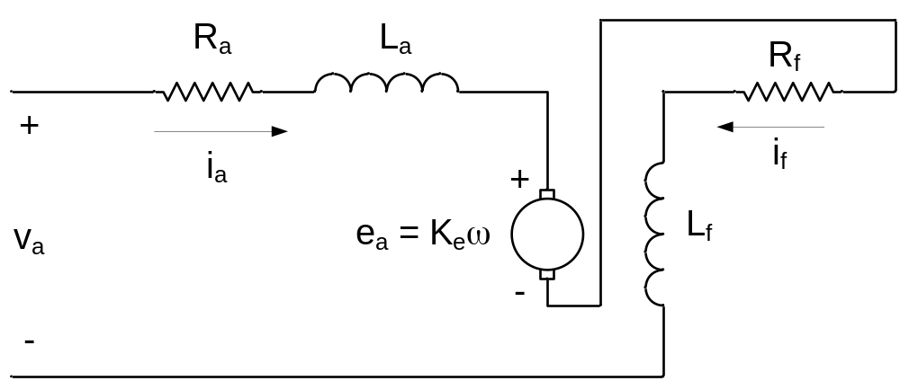
Series Wound DC Motor

T_{ss}(ω) =
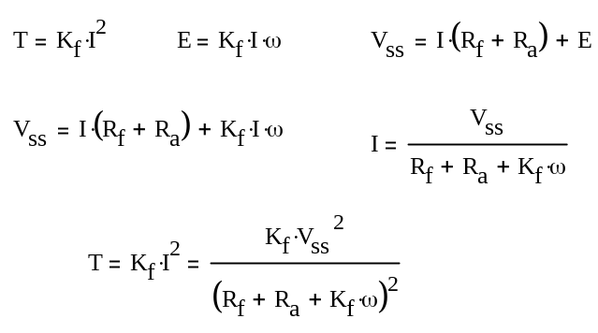

Also known as a Universal Motor (because it will run on AC or DC).

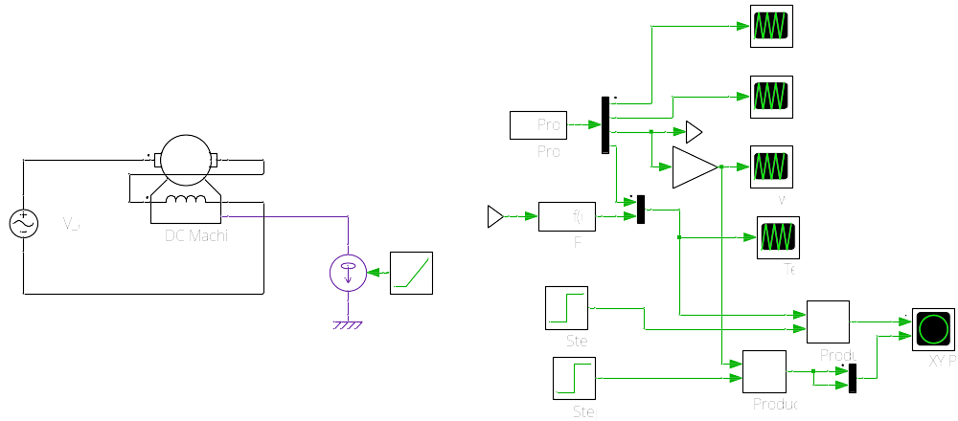
PLECS Model of a Series Wound DC Motor

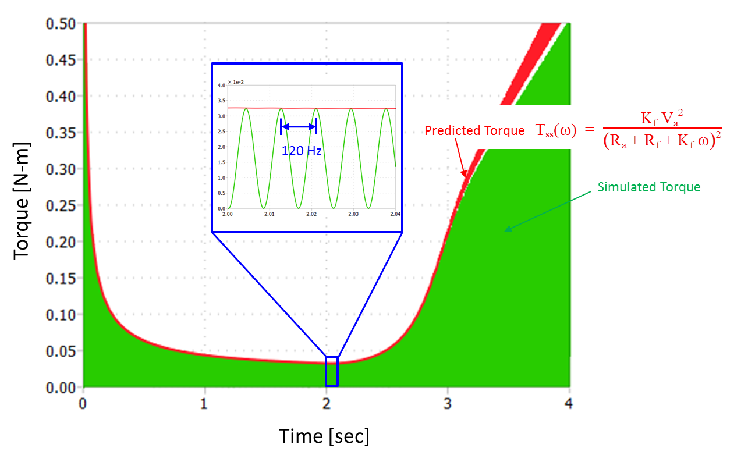
Series Wound DC Motor Simulated and Predicted Torque vs. Time Curves (60 Hz AC Excitation)

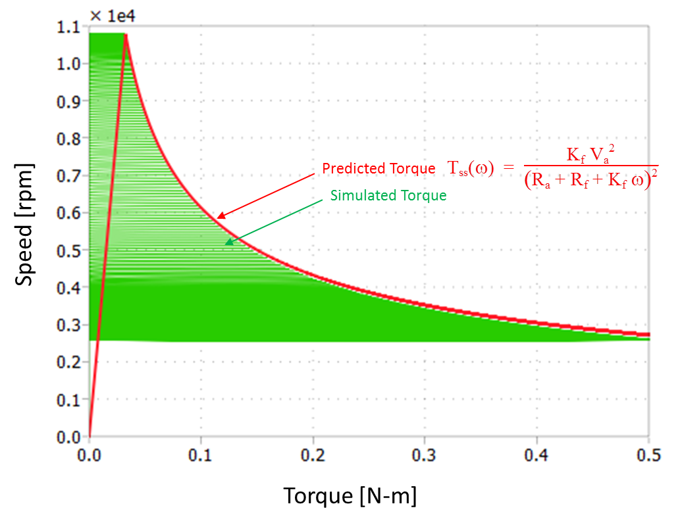
Series Wound DC Motor Simulated and Predicted Speed vs. Torque Curves

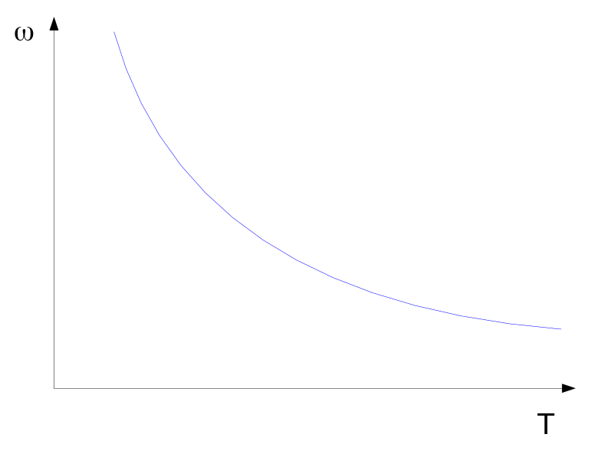
Series Wound DC Motor Speed-Torque Curve

Good for drills, blenders, etc. (high torque at low speed)

Dynamics of DC Machines

v_{a} = R_{a} i_{a} + L_{a} + e_{a}

J = T_{em} – T_{L} – b ω

introduce the LaPlace operator

p → (use ‘p’ instead of ‘s’ in machines)

Equation | Time Domain Representation | LaPlace Domain Representation
Armature | v_{a}(t) = R_{a} i_{a}(t) + L_{a} + e_{a}(t) | V V_{a}(p) = R_{a} I_{a}(p) + L_{a} p I_{a}(p) + E_{a}(p)
Field | v_{f}(t) = R_{f} i_{f}(t) + L_{f} | V_{f}(p) = R_{f} I_{f}(p) + L_{f} p I_{f}(p)
Mechanical | J + b ω(t) + T_{L}(t) = T_{em}(t) | J J s ω(p) + b ω(p) + T_{L}(p) = T_{em}(s)

V_{a} = R_{a} I_{a} + L_{a} p I_{a} + E_{a} (note : use capital letters and drop functional notation)

E_{a} = K_{e} ω
T_{em} = K_{t} I_{a}

J p ω = T_{em} – T_{L} – b ω

I_{a} = ω =

Block Diagram of DC Motor

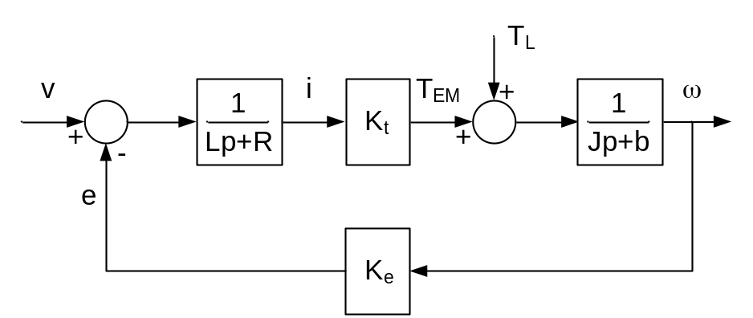
Block Diagram of a DC Machine

ω = ( T_{em} – T_{L}) T_{em} = K_{t} I_{a}

I_{a} = ( V_{a} – E_{a}) E_{a} = K_{e} ω

ω =

ω = V – T_{L}

= speed/voltage TF

= speed/load (disturbance) torque TF

use K = K_{e} = K_{t}

------------------------------------------ ----------------------------------------

for a voltage driven machine:

= = =
implies electrical transients are very fast relative to mechanical

τ_{e} = – electrical time constant

τ_{m} = – equivalent electromechanical time constant if electrical transients are very fast

J = T_{em} – T_{L} – b ω = K i – T_{L} K – T_{L}
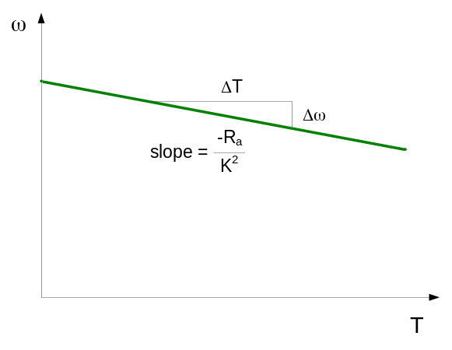
J + ω = K – T_{L}

+ ω = K –

τ_{m} = = J

Assuming electrical transients can not be ignored:

= =

Characteristic Equation:

= 0

Eigenvalues (roots of C.E.)

p = ±

real roots if > → τ_{e} < τ_{m} small machines

complex roots if < → τ_{e} > τ_{m} large machines

Imag | 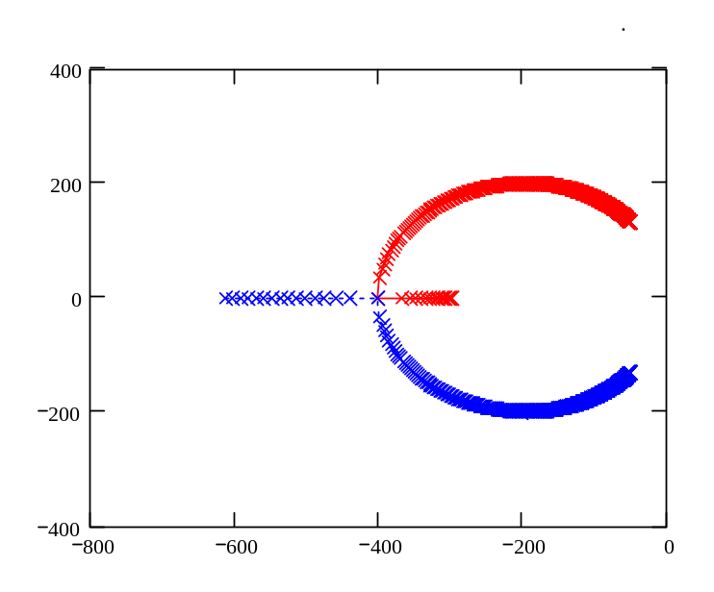  =  A  A  B  B  Real | Speed [p.u] | 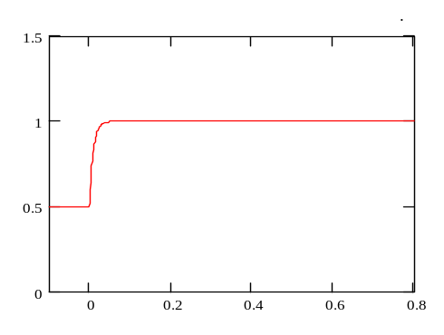  A  ω_{i}  ω_{f}
Imag |  | Speed [p.u.] | 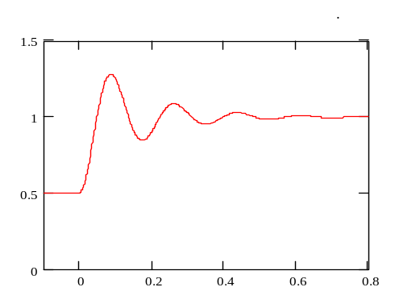  B  ω_{i}  ω_{f}
 |  |  | Time [sec]
Eigenvalue Plot of DC Machine |  | Time Response Plot of Speed with Step Change in Armature Voltage

Properties of 2nd order systems (a controls perspective)

=

For step input:
Unit Step Function
C(p) = R(p) =

c(t) = L⁻¹

c(t) = 1 + sin t ≥ 0

relationship between roots of CE and behavior of step response

p = -ζ ω_{n} ± j ω_{n} = -α ± j ω

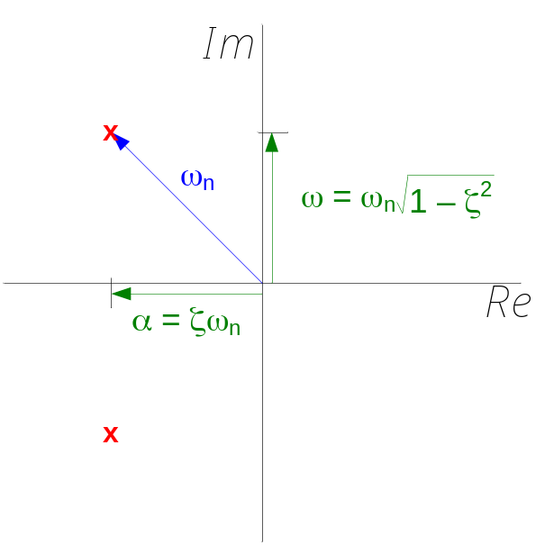
Roots of a 2nd Order System

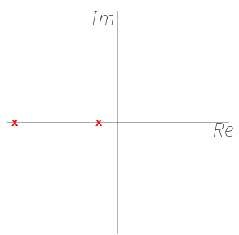 | 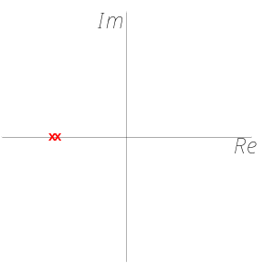 | 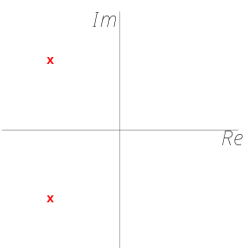
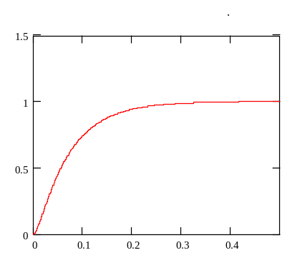 | 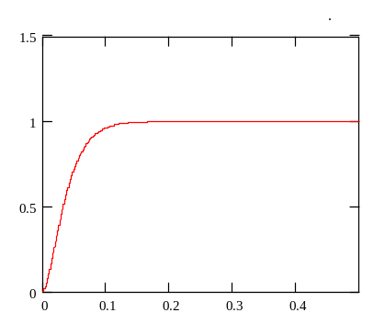 | 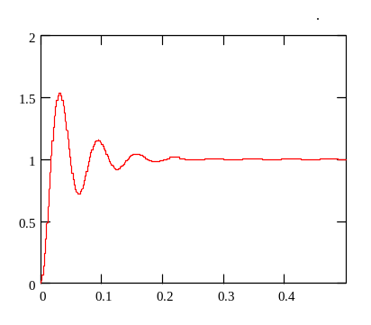
Overdamped | Critically Damped | Underdamped
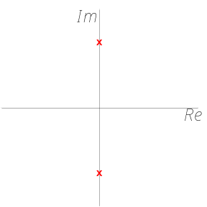 | 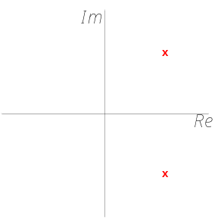 | 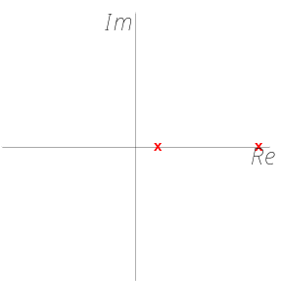
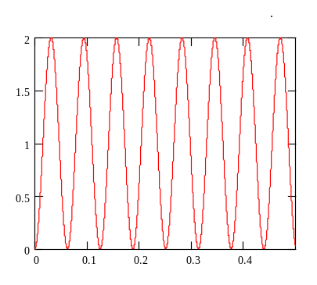 | 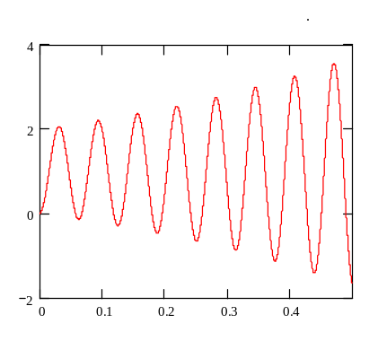 | 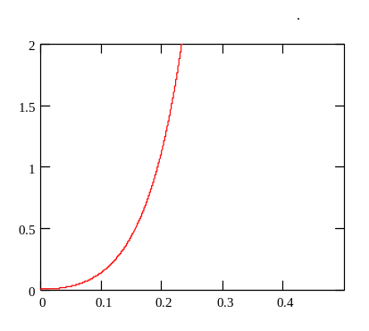
No Damping | Unstable | Unstable
Roots of a 2nd Order System and the Corresponding Step Response

How does small perturbations in voltage effect speed?

=

For sinusoidal inputs, set p → j ω

=

=

=

Note: Brushless DC (BLDC) Machines are actually a special class of AC Machines. BLDC Machines will be covered later in the course.

Introduction to AC Induction Machines:
Basic Theory of Squirrel Cage Induction Machines:

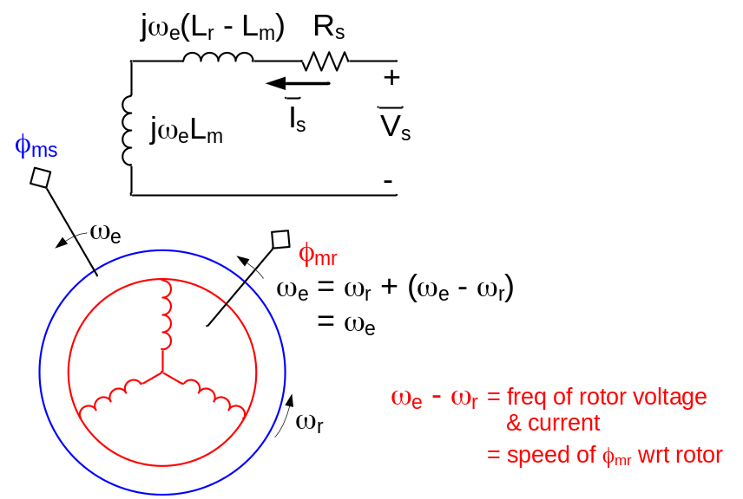 | ω_{e} = excitation frequency  ω_{r} = rotor electrical speed  ω_{em} =  ω_{rm} =

------------------------------------------ ----------------------------------------

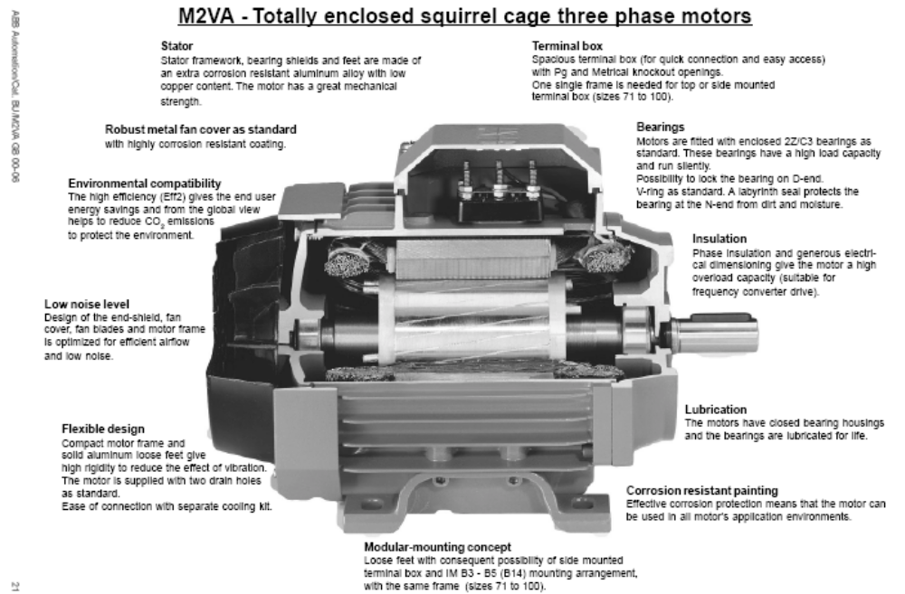
ABB Induction Motor

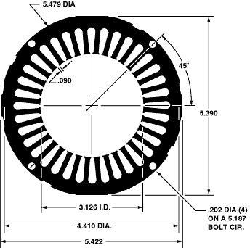   | 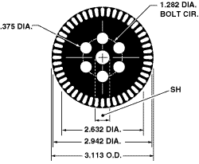
Induction Motor Stator | Induction Motor Rotor
Stator and Rotor Laminations from Tempel Steel Company

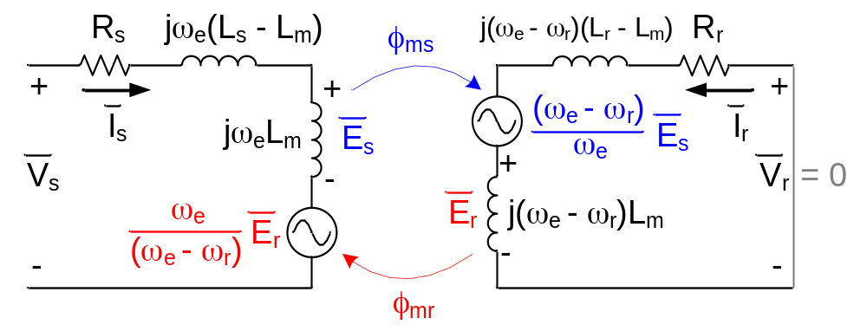
Per Phase Equivalent Schematic of Induction Motor

Circuit Model of Induction Motor

stator: V_{s} = I_{s} + j ω_{e} L_{m}I_{s} + j ω_{e} L_{m}I_{r}

rotor: 0 = j L_{m} I_{s} + j L_{m} I_{r} + I_{r}

multiply rotor equation by = = 0

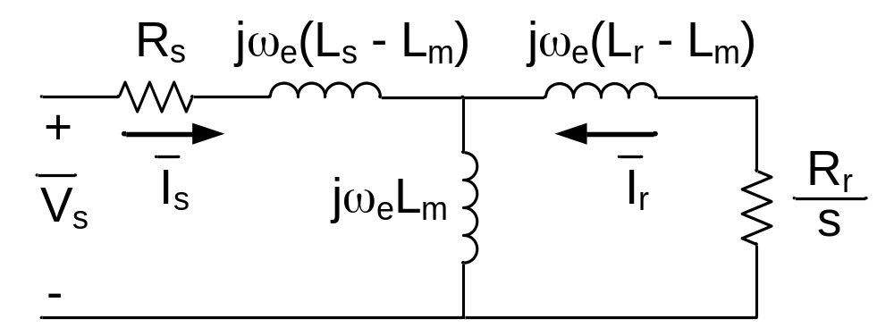
Per Phase Equivalent Schematic of Induction Motor Reflected to Stator

multiply rotor equation by ‘a’ = 0 and introduce a new rotor current =

0 = j ω_{e} a L_{m} I_{s} + j ω_{e} a² L_{m} +

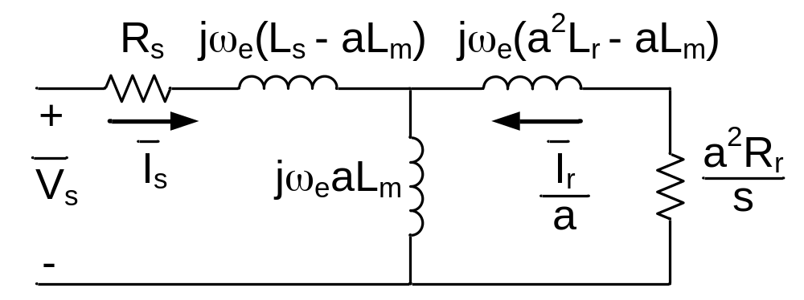
Per Phase Equivalent Schematic of Induction Motor Reflected to Stator

Conventional Per Phase Equivalent Circuit:

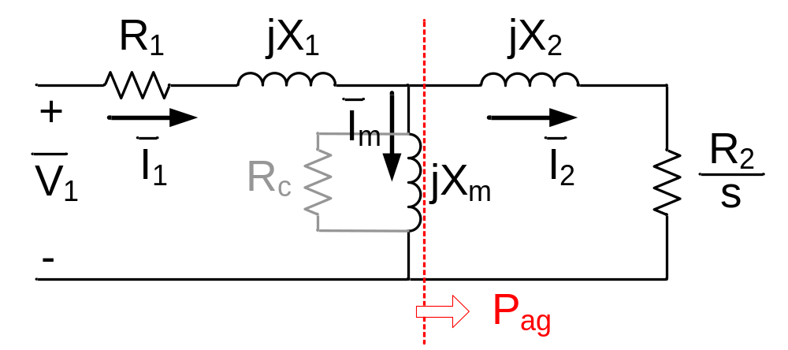
Per Phase Equivalent Schematic of Induction Motor Reflected to Stator

a = R₂ = ²R_{r}
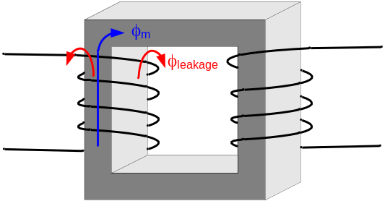

X₁ & X₂ are called “Leakage” Inductances

X₁ = ω_{e}

X_{m} = L_{m} ω_{e}

Airgap Power:

P_{ag} = → 3 I2 R₂ = s P_{ag}

Rotor Loss = s P_{ag}

P_{out} = = P_{ag}

A good (efficient) induction motor must run with low slip.

Electromagnetic Torque:

T_{em} = = = = =

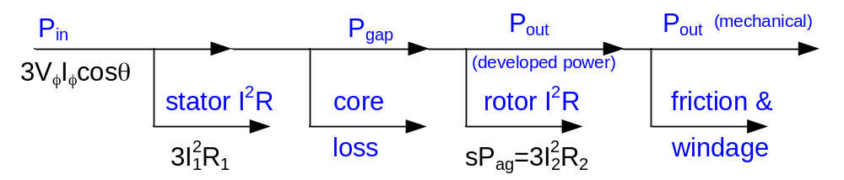
Power Flow in an Induction Motor

What makes a good induction motor?
}
Lots of copper
R₁ → small as economically possible

R₂ → small as economically possible

X_{m} → large as economically possible } Lots of good iron & short air gap

X₁,X₂ → ???

Conventional Per Phase Equivalent Circuit:

Per Phase Equivalent Schematic of Induction Motor Reflected to Stator

T_{em} = P_{ag} = 3 P_{out} = (1 – s) P_{ag}

For a “good” motor

for sure:
R₁ → 0 economics only (amount of wire)
X_{m} → ∞ economics only (small air gap, good magnetic steel)

probably:
Large T_{max} (good)
Large Current at T_{max} (bad)
Large Starting Currents (bad)
R₂ → 0
X₁ , X₂ → 0

Max P_{ag} (assuming small R₁ large X_{m}):

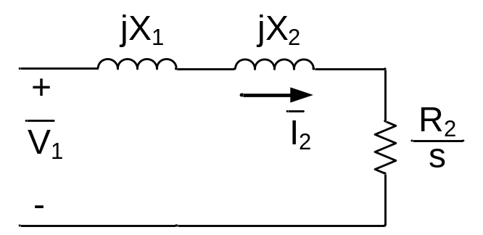
Per Phase Equivalent Schematic of Induction Assuming Small R₁ and Large X_{m}

Max P_{ag} when:

= X₁ + X₂

s_{mt} =

P_{ag_mt} = 3 I2 = = =

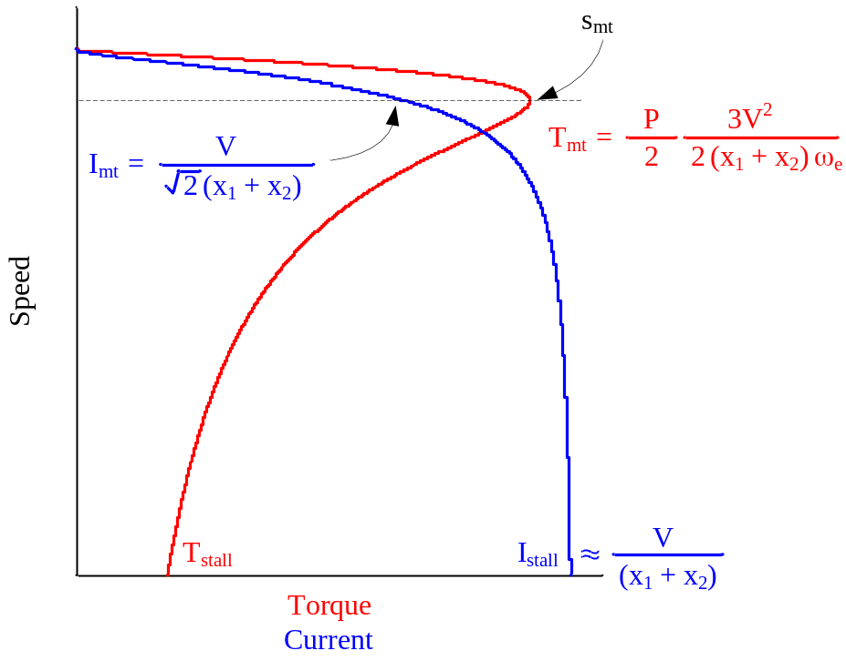
Speed vs. Torque and Current for Three Phase Induction Motor

